Registration Procedure for CDSL Easi/Easiest:

Step 1: Registration for CDSL site
- https://web.cdslindia.com/myeasi/Home/Login
- Click on Register for Easiest
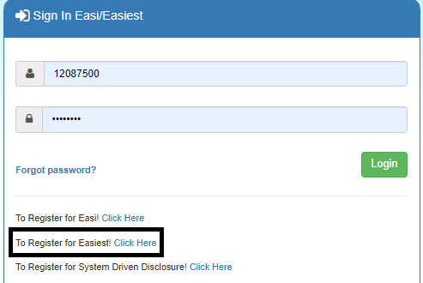
- Enter your 16 Digit Demat Account NumberClick and registerContinue
- Enter OTPEnter Account details and every time choose /trusted Account PINEnter Trusted AccountReceived OTPSubmitContinue
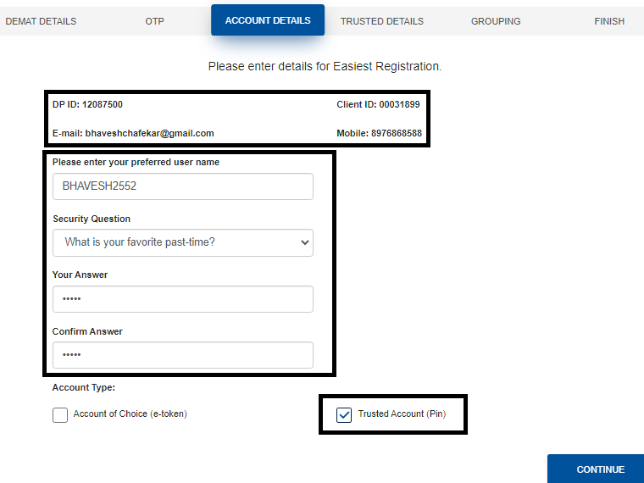
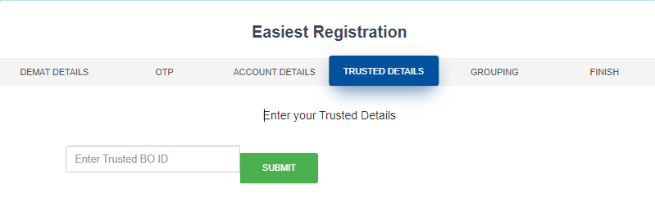
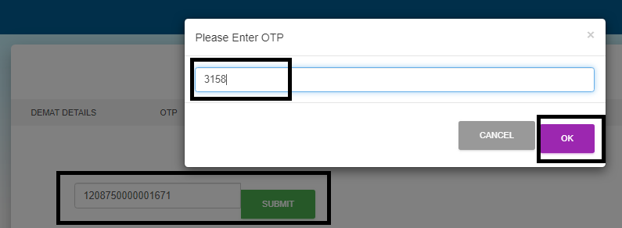
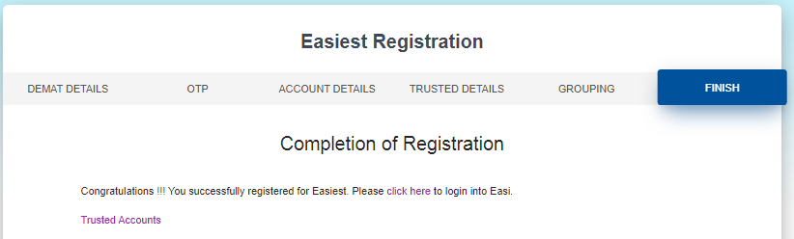
- An OTP will be received on the registered mobile number from CDSL
- The CDSL will ask you certain other details to enter like username, Security Questions etc.
- Here, We Have to select Trusted pin Which will be received on registered mail of that Client after adding trusted account i.e.

Note: PIN Is Important one should remember it after change as it will be used for transaction Process

Your Status Will be shown as Pending For that Contact DP at HO for Authentication

Step 3: Trusted Account Addition
- After Authentication for easiest we have to add Our Pool Account details.
- For that, Select Miscellaneous option from left side 3-line Icon
- In which Select Edit Trusted Account
- Provide Pool Account BOID i.e. (1208750000001671)
- Get it Authenticated By DP.
Note: Once the trusted account gets added the PIN will get generated. It will take 1-2 hours for the pin to generate which will be received in your mail id.
- Once received the client has to change the pin
- For pin change ,Select Miscellaneous option from left side 3-line icon
- In which select change pin option and change it. (Remember the pin should be Alphanumeric no special characters required)
One has to mail the DP regarding addition of details and authentication for
Mail id: dp@kediacapital.com

Step 4: Early Pay in Setup
- Select Transaction Setup option from left side 3-line Icon
- In which Select Early Pay in Setup Option
- There Select Exchange (National Stock Exchange)
- Select Market Type (Rolling Normal)
- Select Settlement ID
- Select CM IDM52028
- Click on get BO Detail
- Select ISIN in which one has to Transact
- Select Quantity of that Particular ISIN
- Select Commit Option to complete the process

Note: Details Marked in Yellow should be considered as Compulsory details which should be selected as per given Criteria.

One Can refer this link for App Registration PROCESS https://youtu.be/1EH4XriTL2Y

