Margin Pledge – Repledge through easiest System

Steps To Margin Pledge for BO:
- Login to the easiest system using his EASIEST login details
- https://web.cdslindia.com/myeasi/home/login
- KEDIA BOID – 12087500-00027544
- Create Margin Pledge Setup
  - Select Easiest Pledge Module Tab
  - Select the Pledgor Option
  - Click on Margin Pledge
  - Click on Pledge Setup -> margin Pledge
  - Enter Pledgee details
  - Enter ISIN details
  - Click on Commit to Setup the Pledge Setup
  - Check for Pledge Setup response whether MP was Success
- Accept the Margin Pledge Setup
  - Accept (COMMIT) the Margin Pledge setup ( Search for the setup entry creted above)
  - On Successful commit of the Margin Pledge transaction, a PSN (Pledge Sequence Number) will be generated.
  - Acknowledge copy will contain the Margin Pledge Details
- OTP Authentication for Margin Pledge Transactions
  - Click on the SMS link received from CDSL for OTP verification
  - Enter his PAN Number details
  - Select all the Margin Pledge transaction you want to approve
  - Click on Generate OTP
  - Enter the OTP sent to your registered Mobile Number & email ID.
  - On successful verification, Margin Pledge will be setup in the system
  - On the execution day, the shares in Margin Pledge will be pledged to the pledgee

BO has to login to the easiest system using his EASIEST login details
  - Visit to CDSL’s Website : https://www.cdslindia.com/index.html
  - Click on Login Tab at the Top right end side

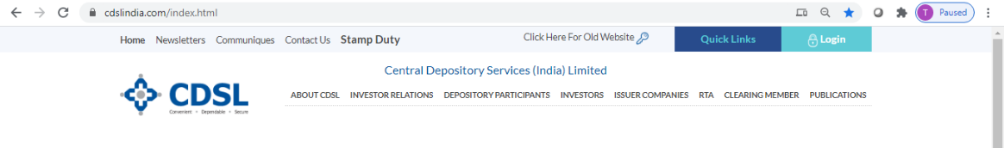

Enter Easiest USER Name and Password
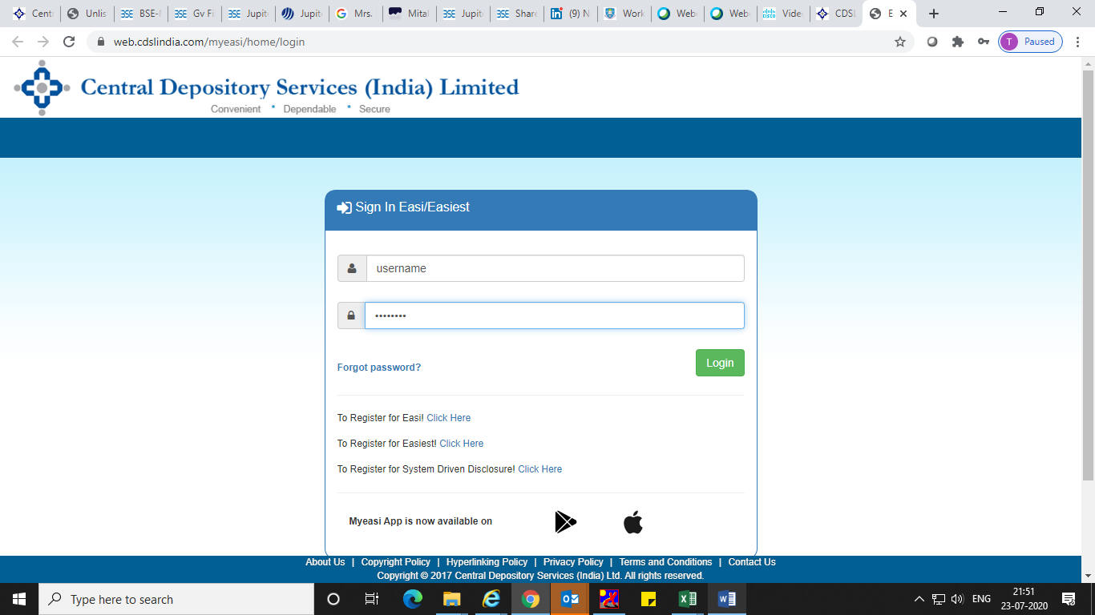

Click on pledge menu in your Easiest login

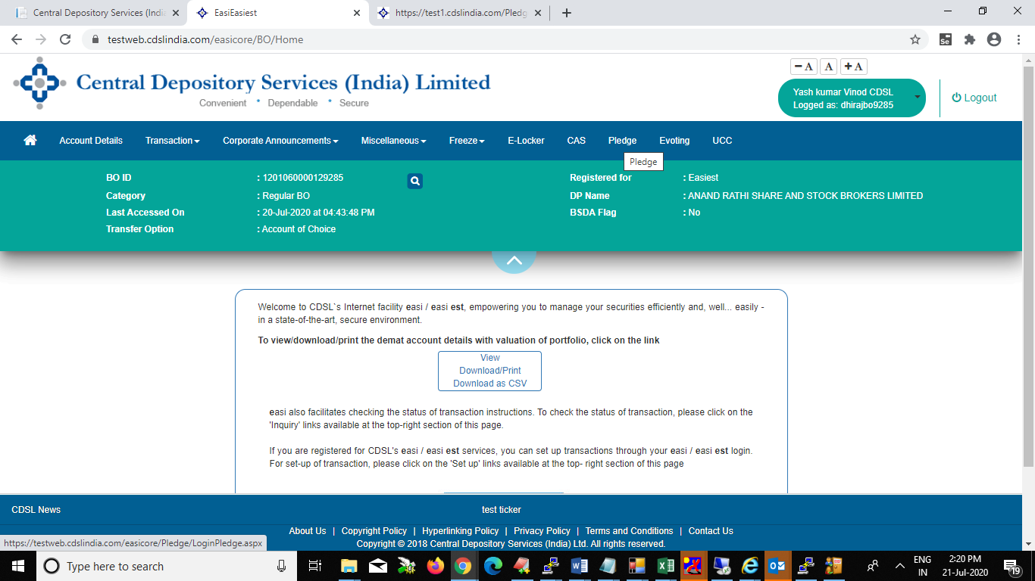

Click on pledgor for Margin pledge setup

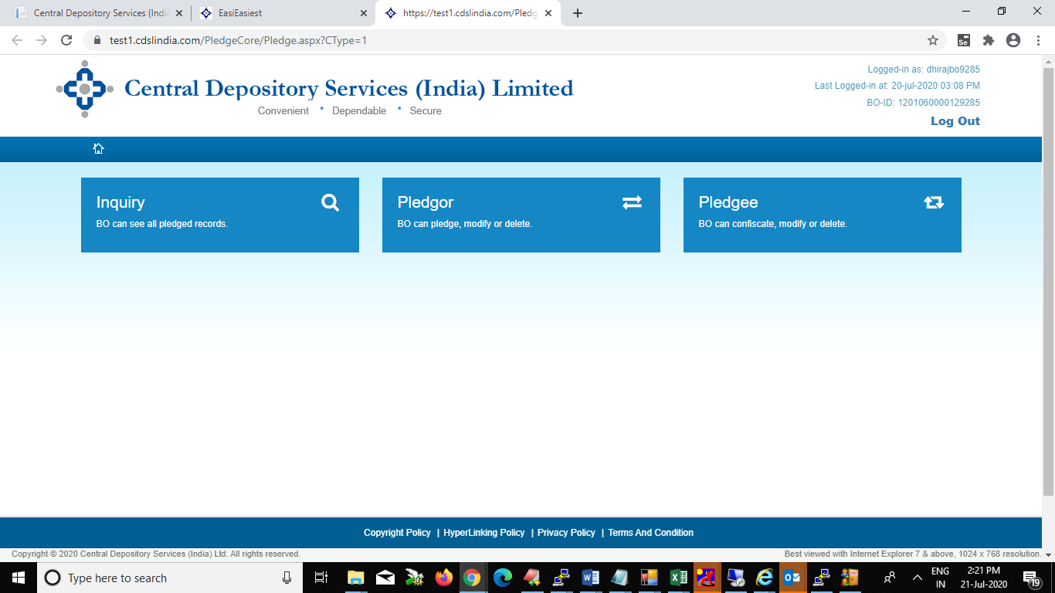

Scroll Down to Pledge Setup Screen (below the Pledge Inquiry Screen)
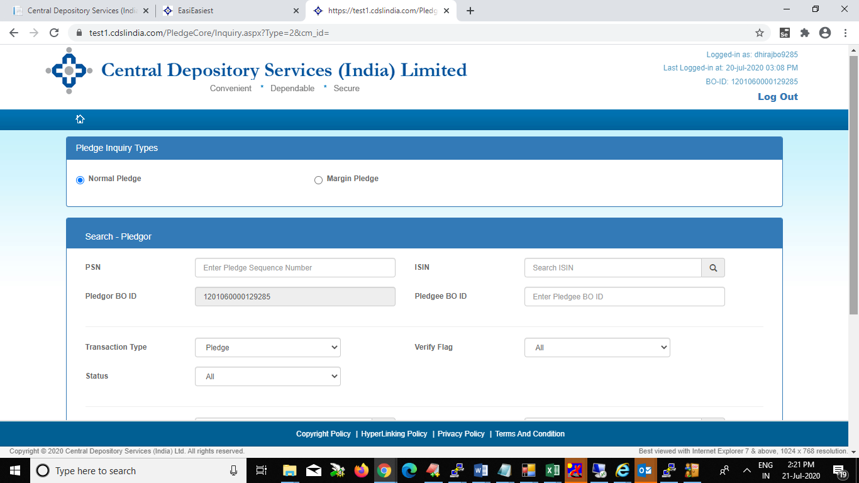

Click on pledge setup
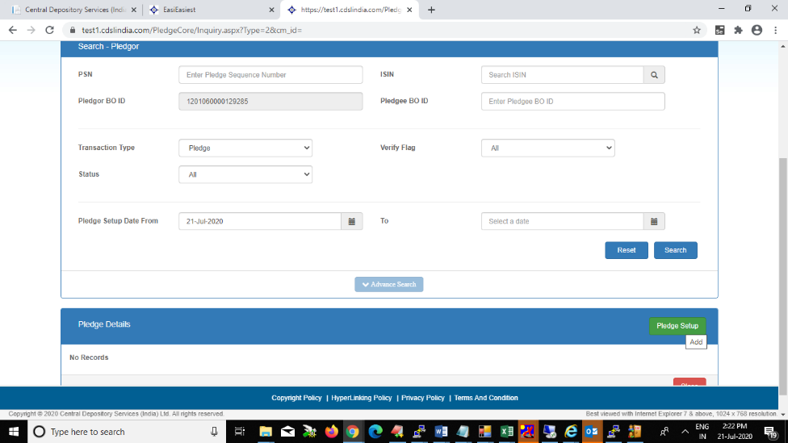
- Click on Margin pledge (Do not click on Normal pledge for margin Pledge related transactions)

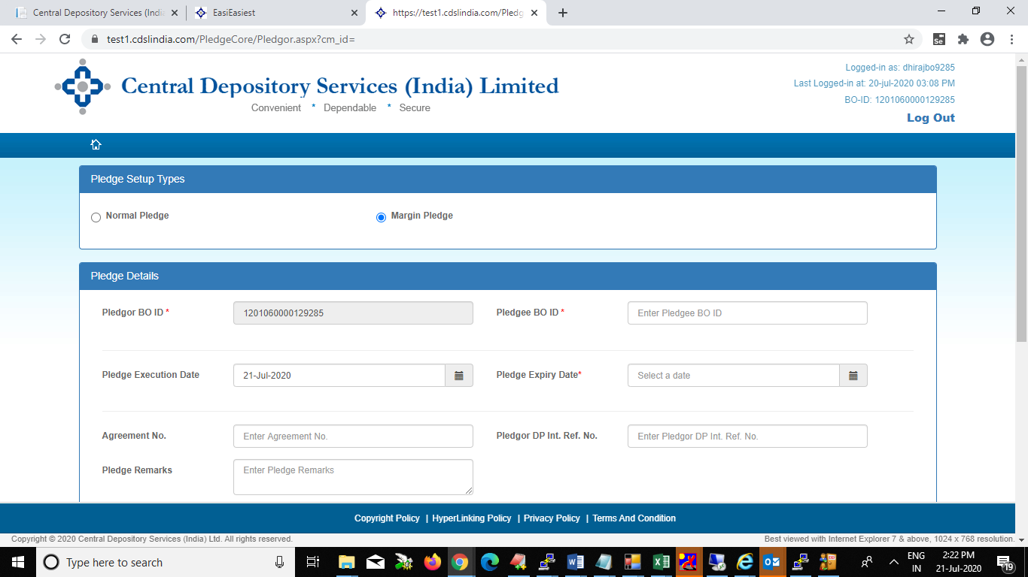

Enter Details of the Pledgee’s (TM or CM or TM/CM) Client Margin Pledge Account -to whom you want to provide margin Pledge
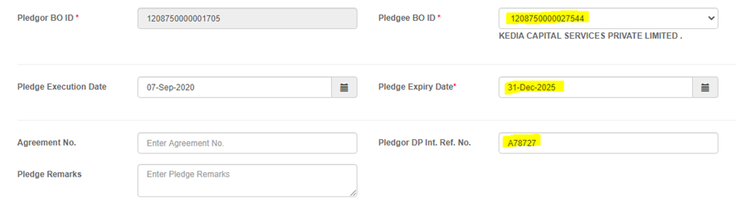
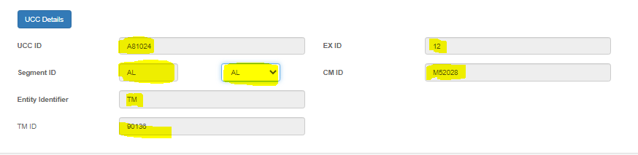
Provide Entity Identifier TM ID in case of BO (CP Code only in case of Custodian Participant) and Click on ADD ( +) Button

- Click on Add (+) Button.

- Provide ISIN details and Pledge quantity and Value & Click on OK

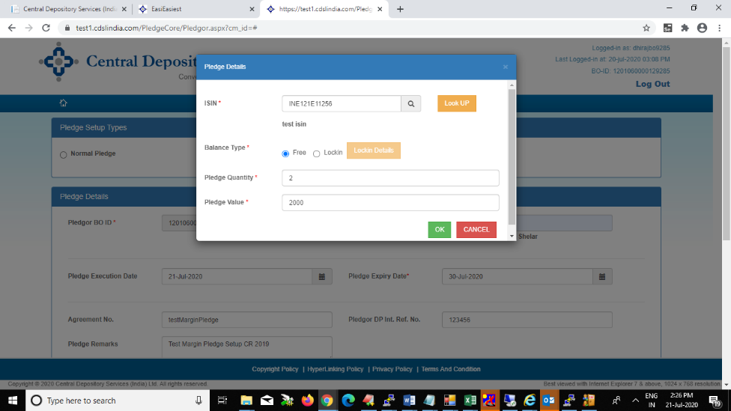

- After you click on Commit, Pledge Setup will be initiated in the system
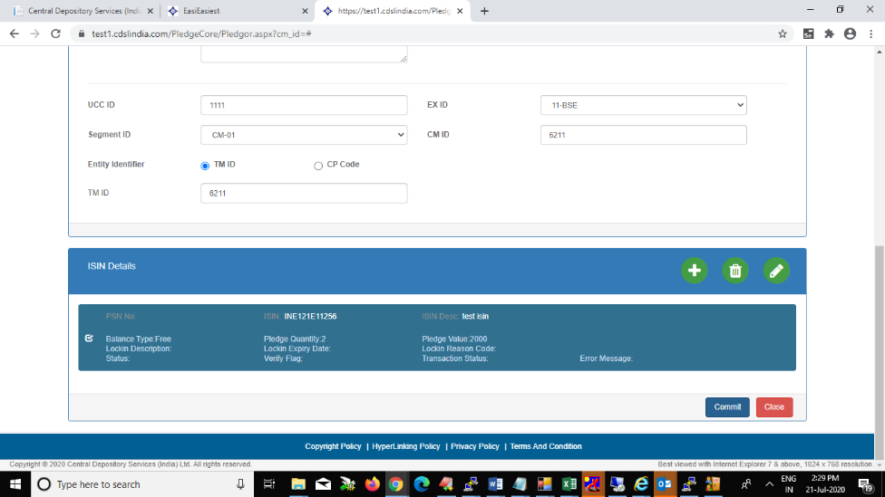

- Pledge Setup response of whether Success or Failure will be displayed on screen
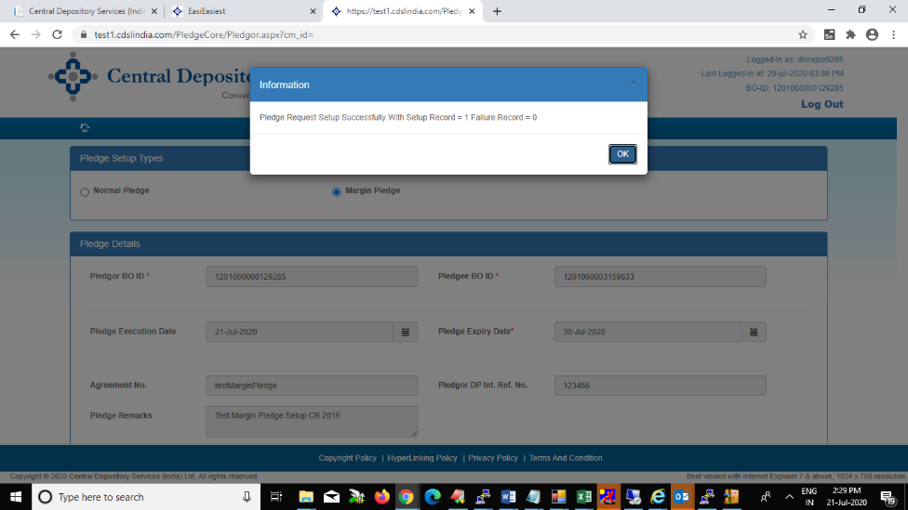

BO has to accept (COMMIT) the Margin Pledge setup. Search for the setup entry and commit. BO also has the option of Deleting and modifying the setup entry made.
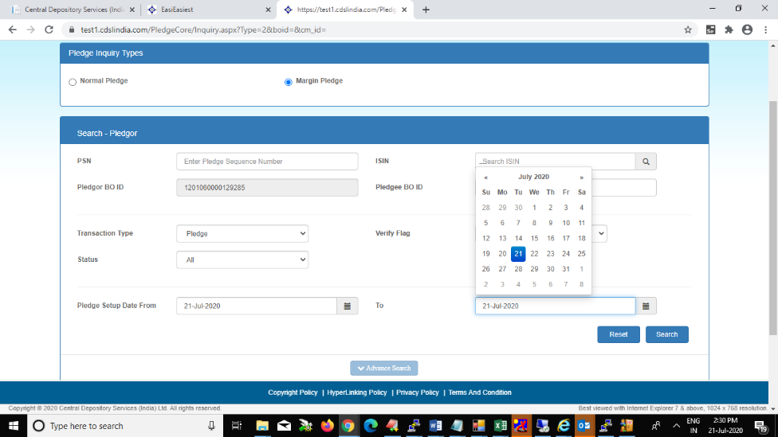

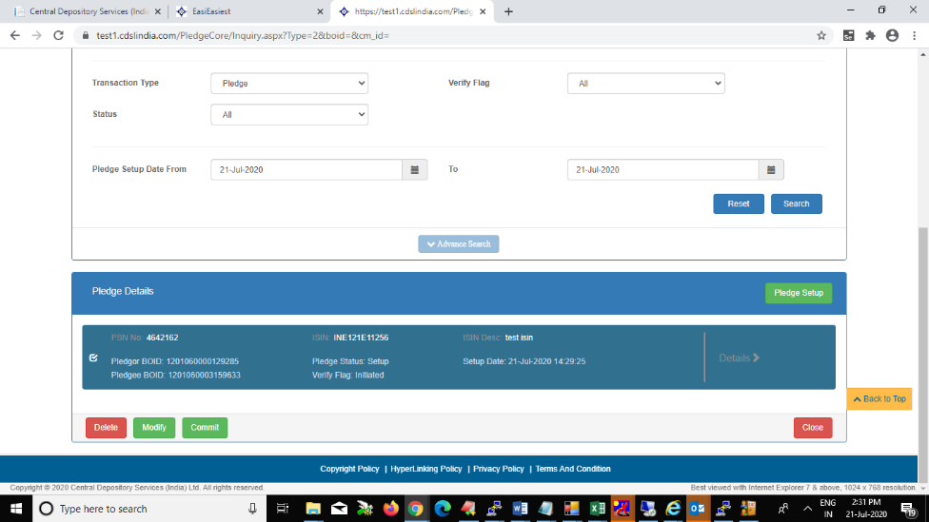

On Successful commit of the Margin Pledge transaction, a PSN (Pledge Sequence Number) will be generated.
System will ask for view of Acknowledge copy of the Setup. Select YES to View the same
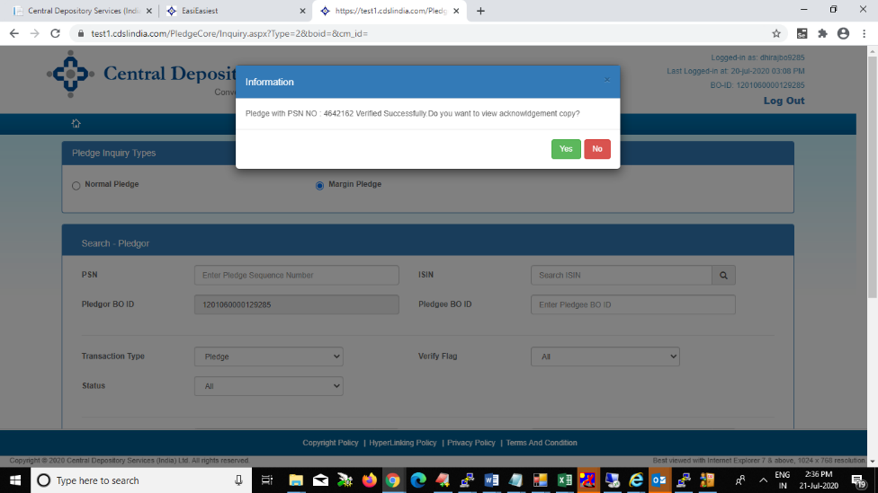

Acknowledge copy after commit will contain the Margin Pledge Details

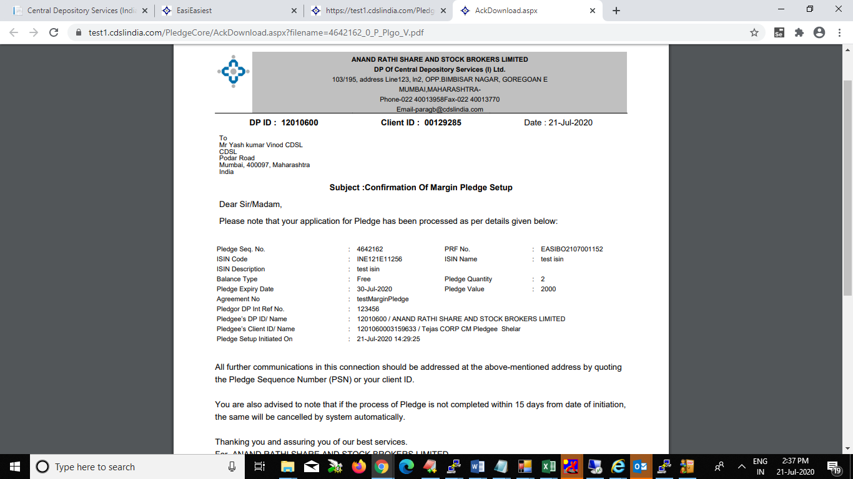

Bo will receive SMS link received for OTP verification
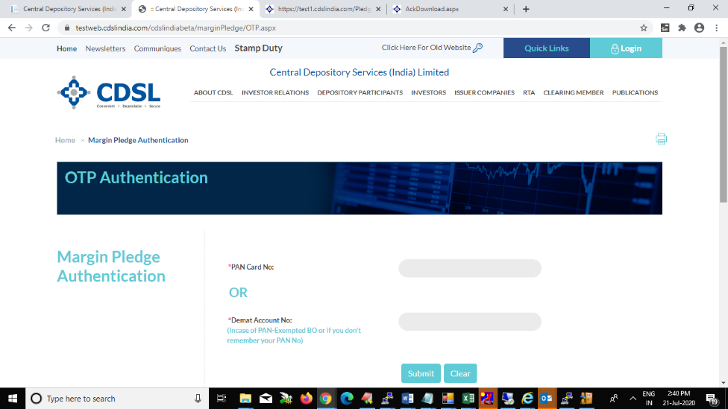

BO has enter his PAN Number details
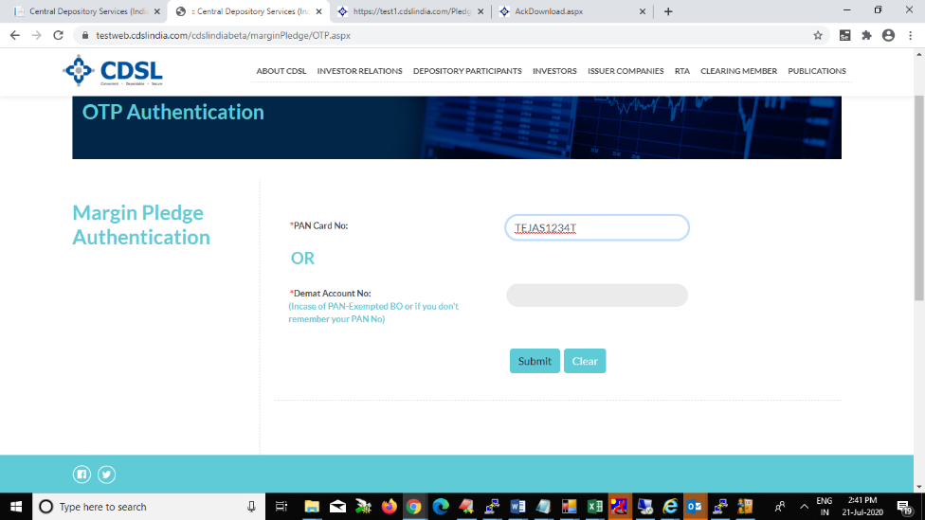

Select (Tick) the checkbox of the Margin Pledge transaction you want to approve and Click on Generate OTP

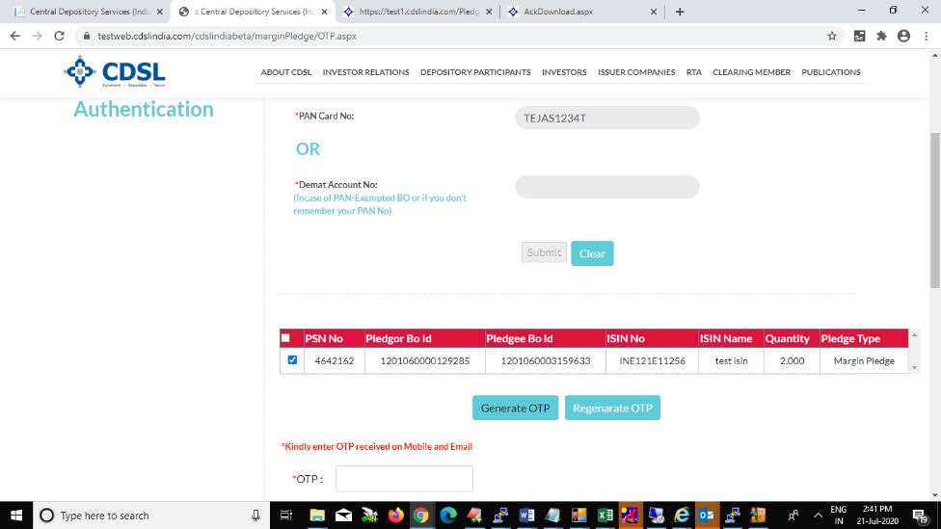
OTP will be sent to your registered Mobile Number and email ID. Please enter the same in the space provided
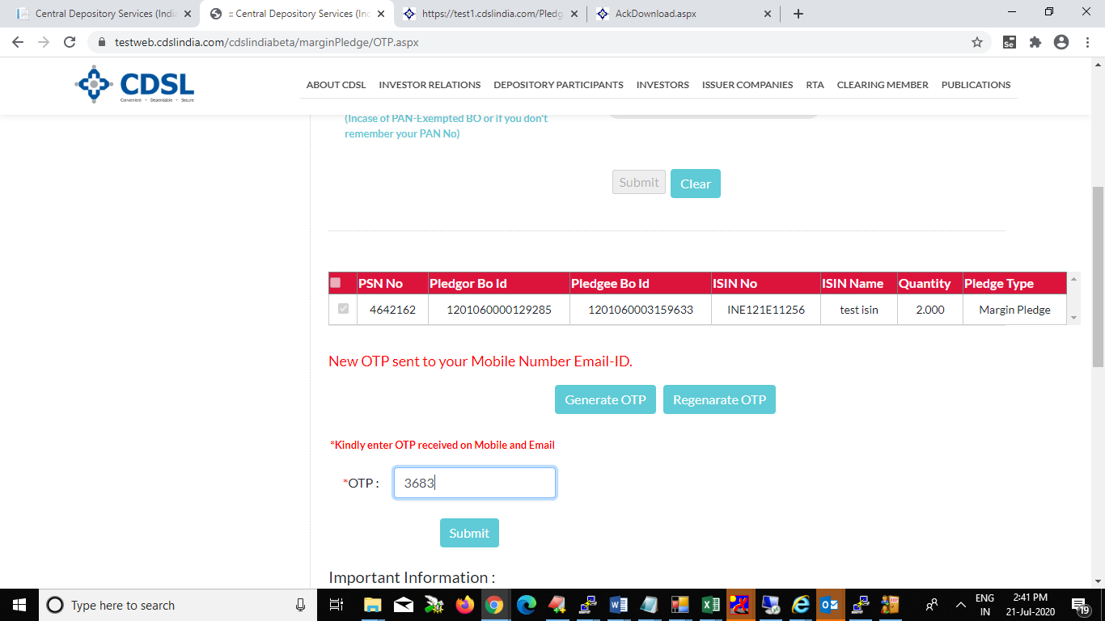

CDSL will provide the success/failure response of the verification. In case of the Success, Margin Pledge will be setup in the system
