Pledge request from BRANCH Login
Go to kedia capital sitehttps://kediacapital.com/Partner loginBack office login
Enter Branch ID and Password and login and Select segmentCap-2122
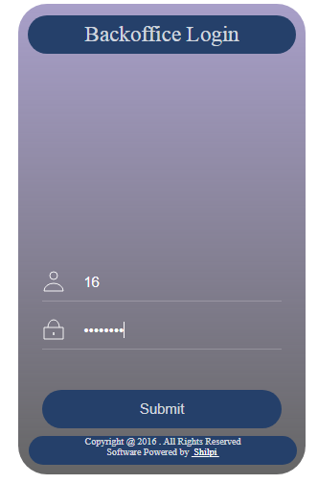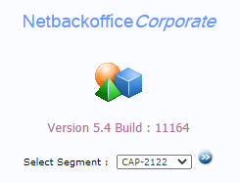

Go to requestMargin Pledge and enter client codeGo
Select ISIN and QTY for pledge
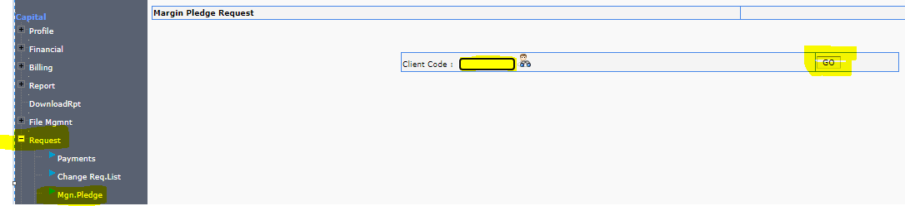

Enter QTY then process and received Transaction ID after this process we will received pledge request in back office.
After received request we will pledge on before 2.30pm.

